**Accelerated Learning Center**

**Aniekan, I referred to your draft website (see link below) to make the following edits and additions. This will start as a simple website the following tabs – Home and Programs.**

[**https://devawinner.github.io/alc-website/about.html**](https://devawinner.github.io/alc-website/about.html)

**HOME ( 1st tab)**

**Please make the following changes to the green banner:**

* Change “Accelerated” to **“Accelerated Learning Center”**
* Change WhatsApp number to **“+1 814 619 5491”**
* Change email address to [drupper@gmail.com](mailto:drupper@gmail.com)



**Insert >>> Bringing Hope to Chuuk**

Chuuk is one of the most geographically isolated regions in the Pacific, spread across dozens of small islands far from major markets, universities, and centers of economic activity. This isolation, combined with chronic underinvestment in education, infrastructure, and healthcare, has contributed to deep social and economic hardships. Opportunities for formal employment are extremely limited and many families **r**ely on subsistence activities or government assistance to survive. Accelerated Learning Center (ALC) believes that with your help we can help the Chuukese rise above these challenges.

Replace "From Classroom to Confidence" heading with

**Empowering the Next Generation to Rise Above Poverty**

At the **Accelerated Learning Center**, we believe every young person deserves the chance to succeed — regardless of where they were born. ALC is grassroots, community-powered nonprofit based in **Chuuk, Federated States of Micronesia**, where access to opportunity is scare, but potential is unlimited.

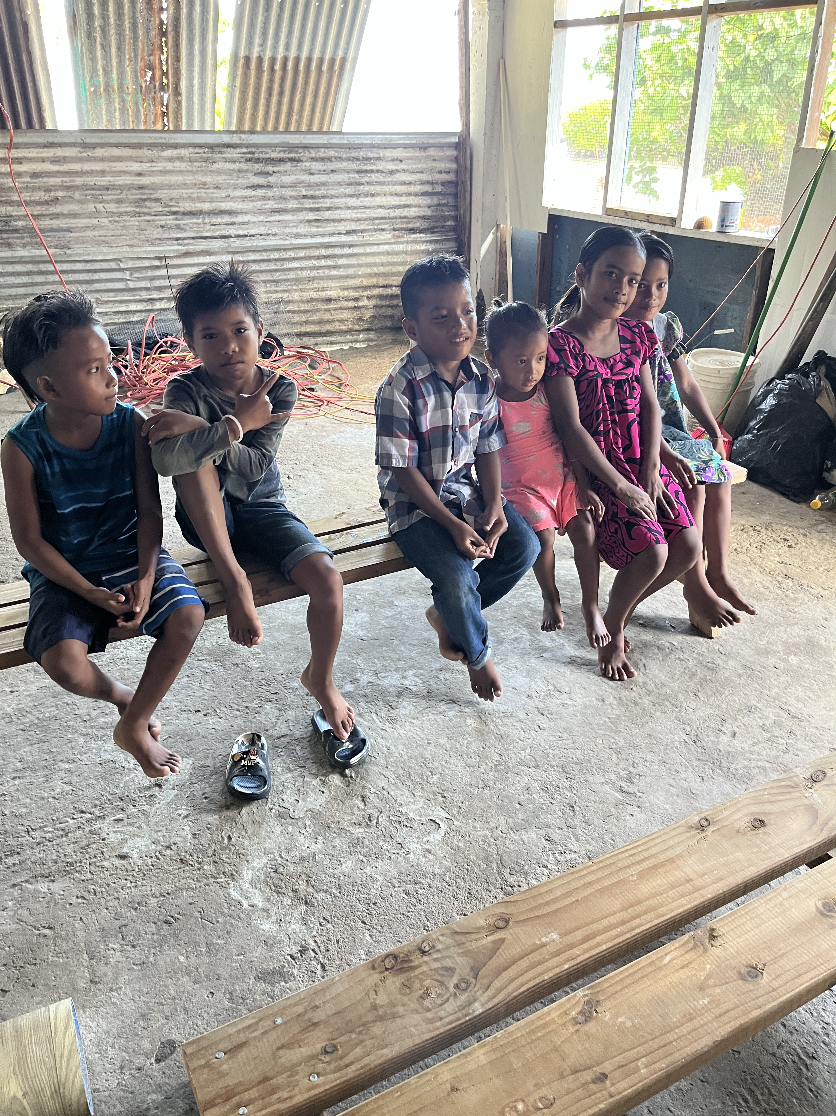

Delete the following from the Home tab:

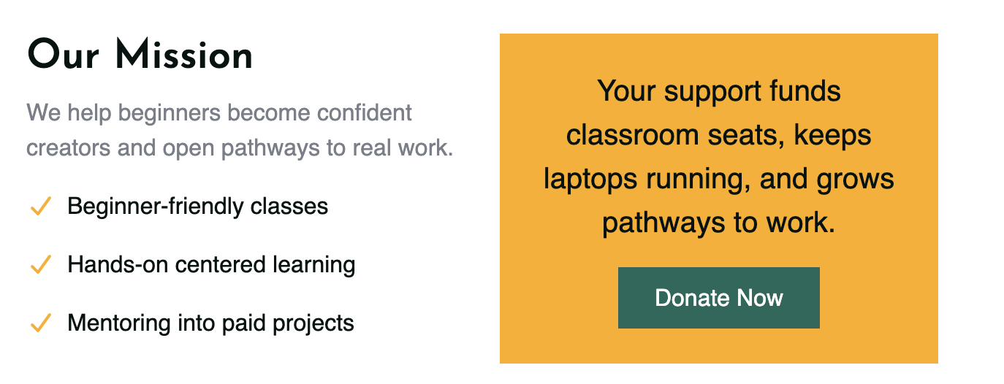

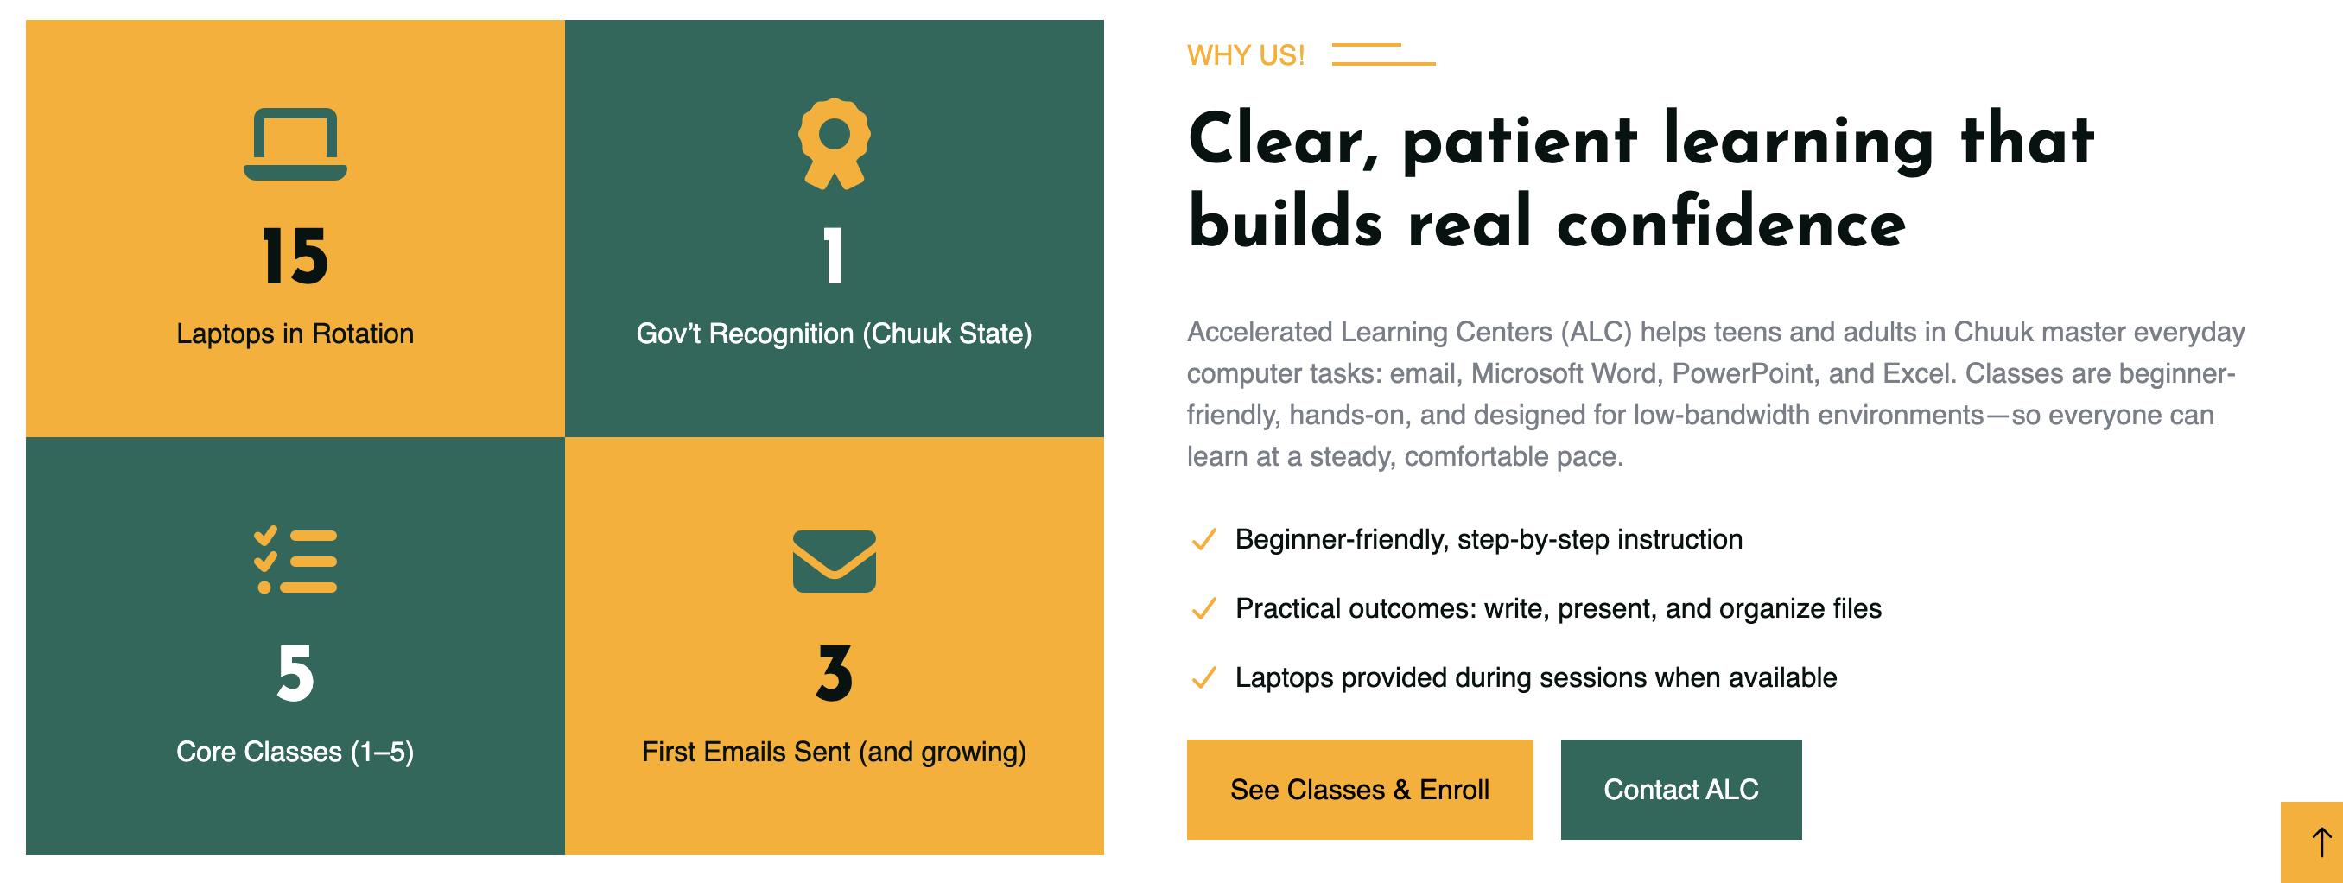

**Keep the following pictures on the Home tab but make the changes highlighted in blue below in the pictures.**

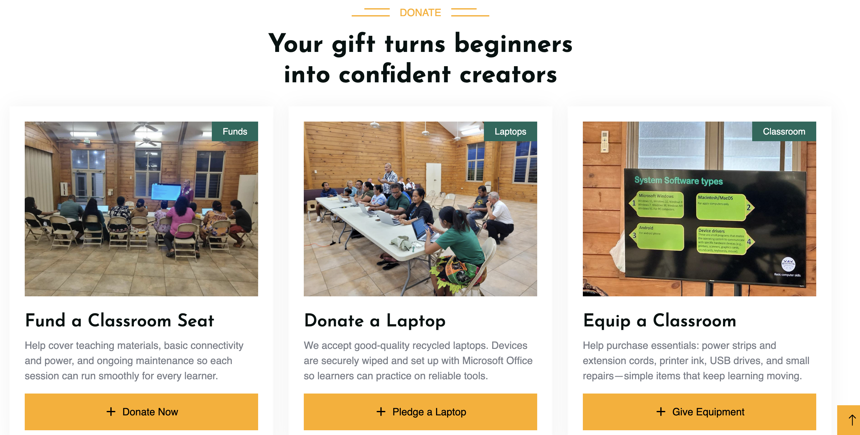

**Change “Your gift turns beginners into confident creators” to “Your gift helps the marginalized learn essential computer skills.”**

**Change “Fund a Classroom” to “Help pay for an instructor”**

**Delete “help cover teaching materials…. To “There are limited number of people in Chuuk capable of teaching computer skills and ALC needs more teachers.”**

**Change “Donate a Laptop” to “Donate money for a Laptop”**

**Delete “We accept good-quality laptops… to “We need more laptops to open new classrooms in Chuuk”**

Keep “ Equip a classroom” the way it is.

Change all three yellow donate button to say “+ Donate Now”

**Rename the “Programs “ tab to “Mission” (2nd tab)**

**Our mission is straight forward:**

**“Equip youth and young adults with the essential skills, discipline, and the confidence they need to transform their futures.”**

** Building Skills and Bridging Gaps**

(Replace the paragraph “Accelerated Learning Centers (ALC) equips teens and adults in Chuuk with practical computer skills – email, Microsoft Word, Power Point and Excel -- so beginners become confident creators” **Instead, insert the following text (in black) next to the classroom with computers (you will need this picture from the Home tab to the new Mission tab)**

Many young people in Chuuk face serious challenges. Their educational system is underfunded and understaffed. Many students graduate with limited literacy, math, and digital skills. Although English is the primary language of instruction, most students speak Chuukese at home, which creates a formidable language barrier. Schools often lack internet access and functional facilities.

(Delete the yellow box that says “See Classes and Enroll)

(Replace the title “Building Skills and Bridging gaps next to the photo of young adults in orange shirts in front of the thatched roof and replace it with the title: “**Creating Hope out of Isolation”**

Accelerated Learning Centers (ALC) equips teens and adults in Chuuk with practical computer literacy— email, Microsoft Word, PowerPoint, and Excel—through patient, hands-on instruction. Learners gain the confidence to communicate, create documents and presentations, and manage simple budgets. Recognized by Chuuk State on **July 18, 2025**, ALC complements existing church and community efforts.

**Keep the following language**

Living on remote islands makes it harder for young adults to connect to global opportunities. That’s why **Accelerated Learning Center (ALC)** was created — to give youth hope and real-world skills so they can build better futures for themselves and their communities.

Keep “Our Mission” and its three checkmarks and text

**Top 3 Challenges ALC Helps Overcome:**

* **Weak educational systems** that leave students unprepared for modern careers
* **High unemployment and lack of job opportunities**, especially for youth
* **Geographic isolation** that limits access to technology, training, and mentoring

**PROGRAMS (2nd tab)**

** What We Do**

** Computer & Digital Literacy**

In today’s world, digital skills are survival skills. Our training includes:

* **Microsoft Word, PowerPoint, Excel**
* Basic computer operation and internet navigation
* Email, cybersecurity and responsible tech use

** Self-Discipline & Growth Mindset**

We mentor students to develop:

* Daily habits for success
* Time management and goal setting
* Resilience, motivation, and confidence

** Mentoring & Coaching**

Each learner is paired with a caring mentor who helps them:

* Set personal and academic goals
* Overcome obstacles and stay motivated
* Explore education & career opportunities
* ** Entrepreneurship & Small Business Training**

ALC teaches students how to:

* + Launch micro-businesses with limited capital
  + Understand budgeting, marketing, and customer service

** Why It Matters**

In Chuuk and other underserved regions, many young adults face:

* + Failing school systems
  + Scarce jobs and few role models
  + A lack of access to technology and guidance

**In addition to the above changes, please:**

Move the following detail from the Home tab to the Classes tab ( 3rd tab)

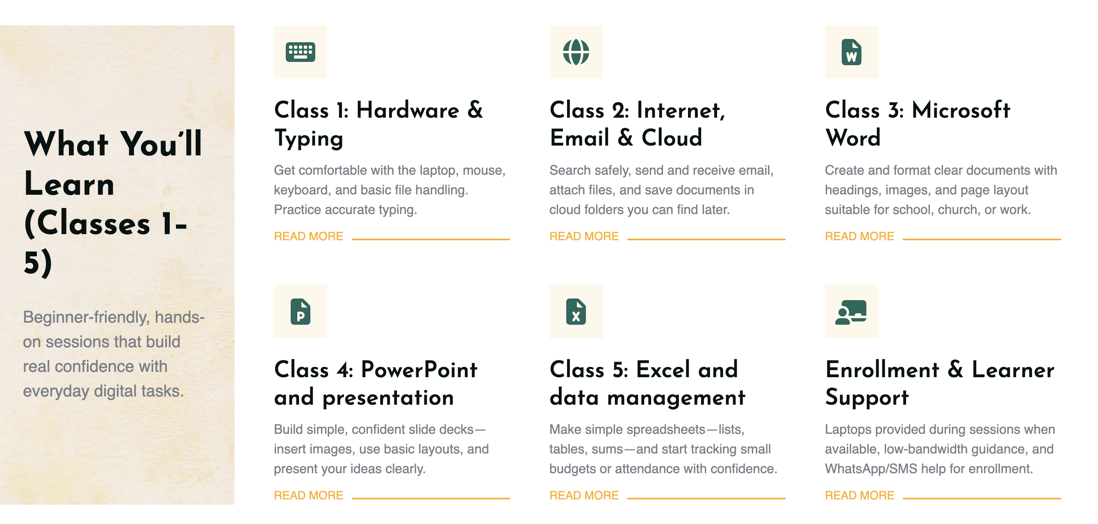

2)  For the "More" tab, modify the drop down tabs to:

* Stories & Impact
* Partners
* Our Team

**Launching Leaders**

On December 26, 2025, Accelerated Learning Center celebrated the graduates from the first ever Launching Leaders class in Chuuk. The class was teaching essential self-improvement skills and resources. These include:

* Developing a growth mindset and understanding time management
* Taking control of your life and defining your core values
* Charting your Course to Success
* Applying a six-step formula to success

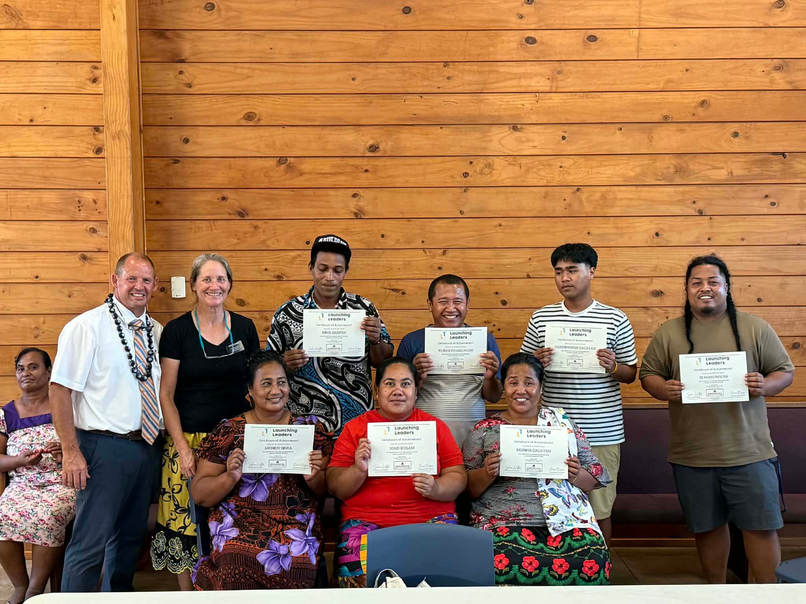

Selina Walter (pictured in the display monitor) taught the class remotely (in Chuukese) from Hawaii. Special thanks to Terri Stillwaugh for coordinating logistics in Chuuk.

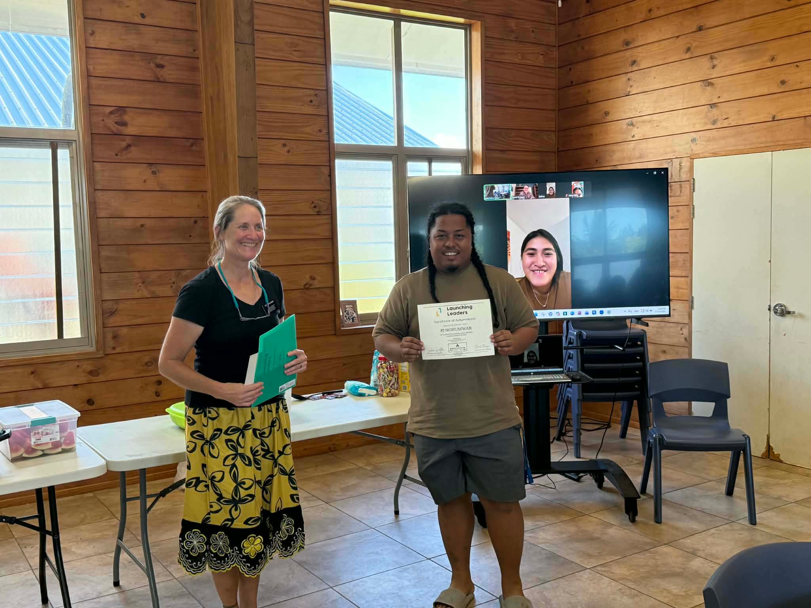

**Mentoring**

Accelerated Learning Center has commenced a program to mentor graduates from our Computer Class and Launching Leaders classes. Each mentoring approach will vary based on the mentee’s skills, interests, and goals.

